ROSSMOYNE SHS SEMESTER 1, 2009
UNIT 3A MATHEMATICS EXAMINATION

SECTION A NON-CALCULATOR SECTION

STUDENT’S NAME _____________________________________

TEACHER:- Belonogoff Goh Hampson
(Circle one name) Knoblauch Lee Robinson
TIME ALLOWED FOR THIS PAPER
Reading time before commencing Section A Five minutes
Working time for Section A (non calculator) Forty minutes
Changeover time between Sections A and B Five minutes
Reading time before commencing Section B Five minutes
Working time for Section B Eighty minutes
Available marks for Section A: 40 marks
Available marks for Section B: 80 marks

MATERIAL REQUIRED / RECOMMENDED FOR THIS PAPER
TO BE PROVIDED BY THE SCHOOL:
This Question/Answer booklet
TO BE PROVIDED BY THE CANDIDATE
Standard Items Pens, pencils, eraser, ruler
Special items Curriculum Council Mathematical Formulae and Statistics Tables Book, drawing instruments, templates, notes on two sheets (4 sides) of A4 paper and calculators (Section B only) satisfying the conditions set by the Curriculum Council.

NOTE: Personal copies of the Tables Book should not contain any handwritten notes, symbols, signs, formulae or any other marks (including underlining and highlighting), except the name and address of the candidate, and may be inspected during the examination.

IMPORTANT NOTE TO CANDIDATES

No other items may be taken into the examination room.
It is your responsibility to ensure that you do not have any unauthorised notes or other items of a non-personal nature in the examination room. If you have any unauthorised material with you, hand it to the supervisor BEFORE reading any further.

STRUCTURE OF THIS PAPER

This paper consists of two sections:
Section A is a non-calculator section – no calculator may be used in this section.
Time allowed for this section is 40 minutes. At the end of 40 minutes, this section will be collected by the supervisor. There will be a 5 minute changeover before commencing Section B.
Section B is a section where approved calculators are permitted. Time allowed for this section is 80 minutes. At the end of 80 minutes, this section will also be collected by the supervisor.

INSTRUCTIONS TO CANDIDATES
ALL questions should be attempted. You may answer the questions in any order you wish.
Write answers in the spaces provided. Extra pages are supplied at the back of this booklet. If the extra pages are used, label the questions clearly. Indicate on the original question that your working continues at the end of this booklet.

Show all working clearly, in sufficient detail to allow your answers to be checked readily and for marks to be awarded for reasoning. Incorrect answers given without supporting reasoning cannot be allocated any marks. If you repeat an answer to any question, ensure that you cancel the answers you do not wish to have marked.

Question | Total | Mark
1 | 5
2 | 2
3 | 4
4 | 2
5 | 3
6 | 7
7 | 3
8 | 3
9 | 2
10 | 2
11 | 4
12 | 3
Total | 40

SECTION A
NO CALCULATORS PERMITTED FOR THIS SECTION
TIME 40 minutes
AVAILABLE MARKS 40 marks
Some formulae you might find useful:

Area of triangle = ab sin C
2
Sine rule 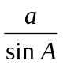 = 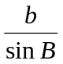 = 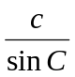

Cosine rule a² = b² + c² – 2bc cos A

Some trigonometry ratios which might be useful:

 | 0⁰ | 30⁰ | 45⁰ | 60⁰ | 90⁰
sin | 0 |  |  | 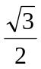 | 1
cos | 1 |  |  |  | 0

Question 1 (2, 3 marks)

(a) Solve (x + 1) = 125

(b) Simplify 3^{n-1} + 3^{n} giving the answer in positive indices.
12 x 3^{n-1}

Question 2 (2 marks)

Simplify, expressing your answer in positive indices.

36 ( a² )³ b⁹
28 a ⁻³ b¹²

Question 3 (2, 2 marks)

Give answers in exact values with a rational denominator. All measurements are in cm.

(a) Find the area of the triangle below.

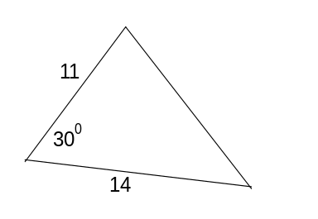

(b) Find the value of x

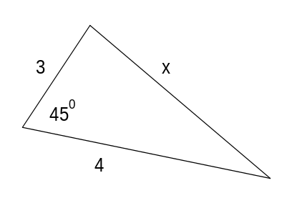
Question 4 (2 marks)

A small high school runs two 3A Mathematics classes. Following a test, the mean mark of the first class of 18 students is 82 and the mean mark of the other class of 25 students is 74.
Explain how the combined mean mark of these two classes would be calculated. (You are not required to calculate it.)

Question 5 (1, 2 marks)

If digits can only be used once.

(a) How many 4 digit odd numbers can made using the digits 2, 3, 4, 5, 6?

(b) How many of the above numbers are greater than 5000?

Question 6 (7 marks)

Describe how the graph of y = 2(x + 2)² compares to that of y = (x - 5 )² - 4. Draw well-labelled sketches of each curve on the same set of axes to support your answer.

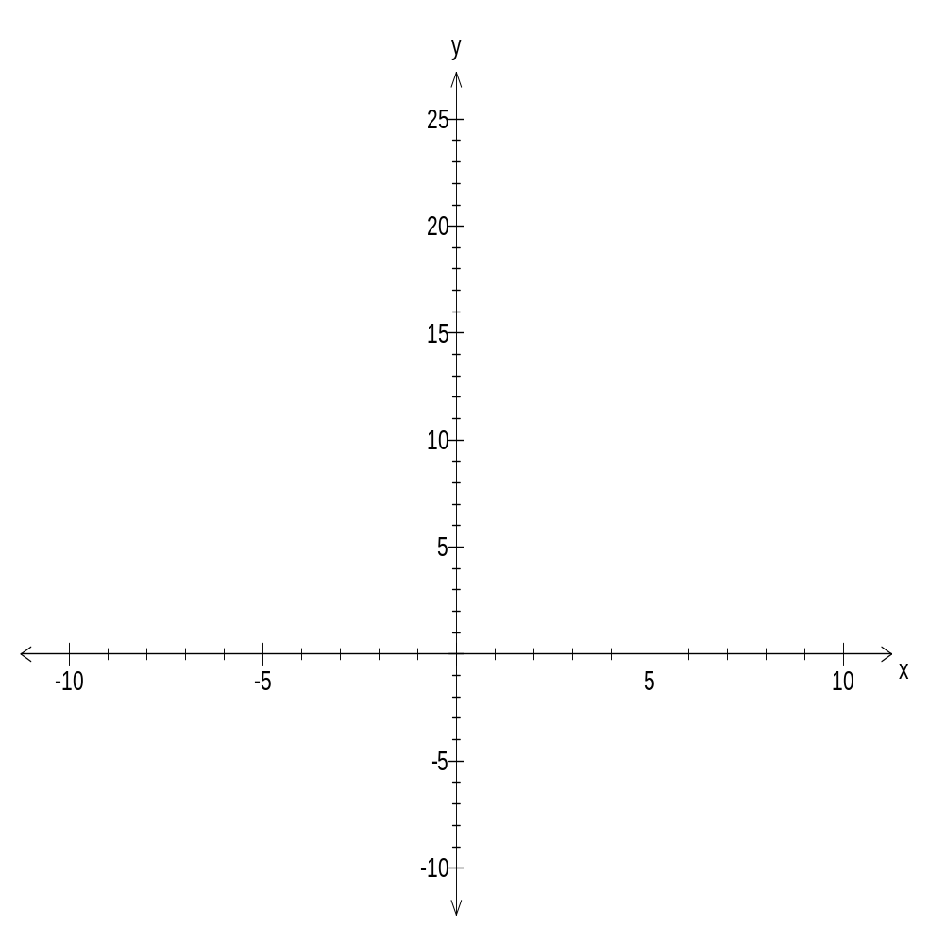

Question 7 (3 marks)

Nine numbers have a mean of m. When a tenth number is added, the mean of all ten is (m – 0.4). What is the tenth number in terms of m?

Question 8 (3 marks)

A sequence has the recursive formula T _{n + 1} = (2)^{-n} T_{n} with T₂ = 4, find T₁, T₃ and T₄ of the sequence.

Question 9 (2 marks)

Write the recursive rule for the sequence below

27, -18, 12, -8, 5 …….

Question 10 (2 marks)

Su-lin’s standardised score in a Mathematics test was 1.4. The mean and standard deviation for the class were 66% and 5.5% respectively. What was Su-lin’s raw percentage mark?

Question 11. (4 marks)

The following scores are arranged in ascending order

a 3 4 5 5 b 7 8 8 9

range = 7 median = 5.5

Find a and b and draw a box and whisker diagram for the above ten scores on the axis below.

_______________________________________________________________

Question 12 (3 marks)

Given that a, b and c are all positive integers, draw a graph that best represents
y = a ( x – b )² ( c – x ). Label all the intercepts.

End of Part A

ROSSMOYNE SHS SEMESTER 1, 2009
UNIT 3A MATHEMATICS EXAMINATION

SECTION B APPROVED CALCULATORS PERMITTED

STUDENT’S NAME _____________________________________

TEACHER:- Belonogoff Goh Hampson
(Circle one name) Knoblauch Lee Robinson

TIME ALLOWED FOR THIS PAPER
Reading time before commencing Section A Five minutes
Working time for Section A (non calculator) Forty minutes
Changeover time between Sections A and B Five minutes
Reading time before commencing Section B Five minutes
Working time for Section B Eighty minutes
Available marks: 120 marks

MATERIAL REQUIRED / RECOMMENDED FOR THIS PAPER
TO BE PROVIDED BY THE SCHOOL:
This Question/Answer booklet
TO BE PROVIDED BY THE CANDIDATE
Standard Items Pens, pencils, eraser, ruler
Special items Curriculum Council Mathematical Formulae and Statistics Tables Book, drawing instruments, templates, notes on two sheets (4 sides) of A4 paper and calculators (Section B only) satisfying the conditions set by the Curriculum Council.

NOTE: Personal copies of the Tables Book should not contain any handwritten notes, symbols, signs, formulae or any other marks (including underlining and highlighting), except the name and address of the candidate, and may be inspected during the examination.

IMPORTANT NOTE TO CANDIDATES

No other items may be taken into the examination room.
It is your responsibility to ensure that you do not have any unauthorised notes or other items of a non-personal nature in the examination room. If you have any unauthorised material with you, hand it to the supervisor BEFORE reading any further.

STRUCTURE OF THIS PAPER

This paper consists of two sections:
Section A is a non-calculator section – no calculator may be used in this section.
Time allowed for this section is 40 minutes. At the end of 40 minutes, this section will be collected by the supervisor. There will be a 5 minute changeover before commencing Section B.
Section B is a section where approved calculators are permitted. Time allowed for this section is 80 minutes. At the end of 80 minutes, this section will also be collected by the supervisor.

INSTRUCTIONS TO CANDIDATES
ALL questions should be attempted. You may answer the questions in any order you wish.
Write answers in the spaces provided. Extra pages are supplied at the back of this booklet. If the extra pages are used, label the questions clearly. Indicate on the original question that your working continues at the end of this booklet.

Show all working clearly, in sufficient detail to allow your answers to be checked readily and for marks to be awarded for reasoning. Incorrect answers given without supporting reasoning cannot be allocated any marks. If you repeat an answer to any question, ensure that you cancel the answers you do not wish to have marked.

Question | Total | Mark
1 | 8
2 | 8
3 | 4
4 | 6
5 | 2
6 | 6
7 | 5
8 | 6
9 | 6
10 | 6
11 | 5
12 | 5
13 | 4
14 | 5
15 | 4
Total | 80

SECTION B
APPROVED CALCULATORS PERMITTED FOR THIS SECTION
TIME: 80 minutes
MARKS ALLOCATED 80 marks

Question 1. (3, 2, 3 marks)

Of the 130 people at a conference, 52 were male and 97 were 40 years or older. The number of
female delegates younger than 40 years was half that of males less than 40 years old.

- Show the above information in a Venn diagram.

- How many delegates were male aged 40 years or more?

(c) What is the probability that a person chosen at random will be

  - a male aged less than 40 years? __________________________

  - a female aged under 40 years? __________________________

  - a female given she is at least 40 years old? __________________________

Question 2. (2, 1, 1, 2, 2 marks)

A doctor notes that in the last two years, 24 of his patients were diagnosed with some form of cancer.
18 of these patients had been exposed to harmful chemicals in their workplace. 5 had not been exposed to chemicals but were smokers. A total of 20 patients were smokers. Represent this information in a two way table and use it to answer the following.

What is the probability that one of his cancer patients

- is neither a smoker nor has been exposed to chemicals? _____________________

(b) is a smoker but has not been exposed to chemicals? _____________________

(c) is a smoker given that he/she has not been exposed to chemicals? _____________________

(d) is not a smoker given he/she has been exposed to chemicals? _____________________

Question 3. (1, 1, 2 marks)

Aziz is driving across the Nullabor to Melbourne and taken a collection of these CDs –
2 Country and Western, 3 Jazz, 2 modern music and 4 classical music.

In how many ways can he listen to all of them if

(a) he does not mind the order?

(b) the Country and Western CDs are the first and the last CDs?

(c) he listens to the Country and Western ones first, then the Jazz, then the modern music ones and finally the classical CDs?
Question 4. (1, 1, 1, 1, 1, 1 marks)

Match the correct equations with the graphs below. Use the letter (eg A, B etc) and not the
equation.

A y = 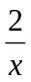 B y = 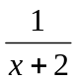 C y = 2 
D y = 2 ^{(x + 1)} E y = 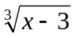 + 4 F y = (x + 4)² - 9

G y = ( x - 4)³ + 2 H y = 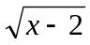 + 1 I y = 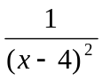 + 3

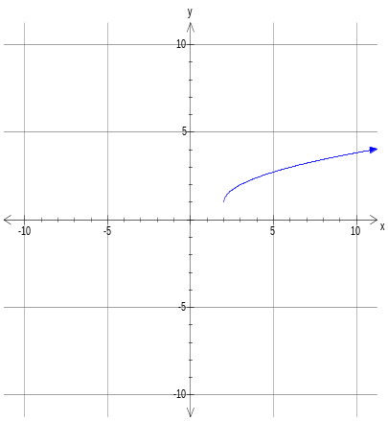 | 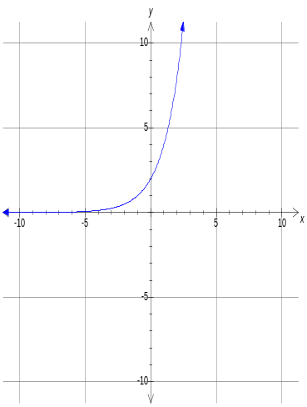 | 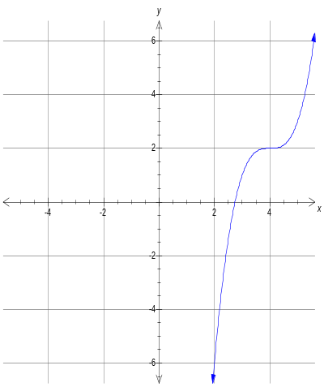
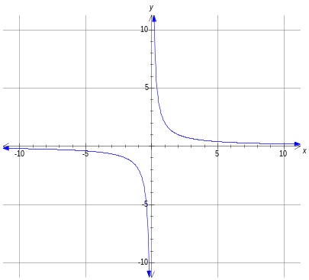 | 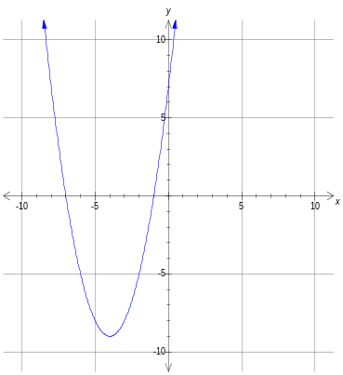 | 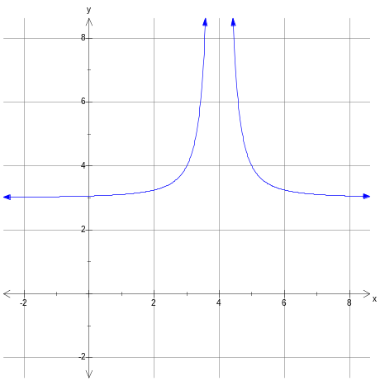

Question 5. (2 marks)

The Health Department needs an estimate of patients infected with Porcine Flu. The names on List A
are patients who exhibit symptoms of the disease, List B has some names of people from the Procine Flu Association.. List A had 263 names. List B had 127 names of whom 81 were also on List A.

- How many sufferers of Porcine Flu do these figures suggest exist in the population as a whole?

(b) How many of these do not feature on either list?

Question 6. (2, 1, 2, 1 marks)

In 1990 it was noticed that the population of rock wallabies in Wayugal Reserve was increasing
according to the equation y_{w} = 40 + 0.1(x² + 20x) whilst the population of feral goats in the
same area was increasing according to the equation y_{g} = 20 (1.09)^{x} where x is the number of years
after 1990. Use your CAS calculator to answer the following questions.

- How many
  - rock wallabies were there in 1990? __________________________________

(ii) feral goats were there in 1990? __________________________________

(b) In which year and month will the two populations equal each other if these rates of increase are
maintained?

(c) In 2005, the shire council removed forty goats from the population in an eradication
programme. If, after the eradication, the two populations will still continue to increase at the same rates, write the equations of the growths of the rock wallabies and feral goats from 2005
onwards.

- In which year will the two populations equal each other? __________________

Question 7. (2, 3 marks)

L varies directly proportional to x and inversely proportional to 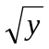 . If L = 24 when
x = 2 and y = 9

- Find L in terms of x and y.

- Find the exact value of x when L = 8 and y = 72.

Question 8. (3, 3 marks)

In the first month of operation a small gold mine produced 200 troy ounces of gold. (The mass of gold is defined in troy ounces where 1 troy ounce = 31.103 g.) In the second month 280 troy ounces were produced. In the third month it produced 392 troy ounces of gold. Successive monthly production figures formed a geometric sequence until full production is reached in the fifth month. Thereafter, this amount is maintained.

- What is the maximum monthly production of the gold mine?

- What total amount of gold in troy ounces was produced in the first twelve years of its operation?

Question 9. (3, 3 marks)

Solve the following. All working must be shown.
(a) 7^{3n+2} x 7^{1-n} = 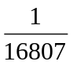

- 3^{2n} - 12 (3^{n}) = -27

Question 10. (2, 2, 2 marks)

All the letters of the word FORMULA are to be arranged at random in a row.

- How many of these arrangements have the three vowels next to each other?

- How many of these arrangements have the vowels and the consonants occupying
alternate positions?

- What is the probability that the ‘word’ commences with an M and the vowels are
together?
Question 11. (2, 3 marks)

The frequency table below shows the weekly wages earned by some students who have
part-time jobs.

Weekly earnings ($) | Number of students
0 - 9 | 10
30 - 39 | 3
40 - 49 | 5
50 - 59 | 4
60 - 69 | 11
70 - 79 | 7
80 - 89 | x

(a) If x = 2, find the mean and standard deviation for the students’ weekly earnings.

- Find the value of x if the mean is 54.5. Show clearly how you obtained your answer.

Question 12. (2, 1, 2 marks)

Kumar borrows $25 000 at interest rate of 5.5% p.a.. He agrees to pay $5 000 at the end of each year.

- Write the recursive rule used to calculate the amount Kumar will owe at the end of
each year.

- In which year will he owe less than $10 000?

- After how many years will he finally pay off his loan? What will Kumar’s final payment be?

Question 13. (4 marks)

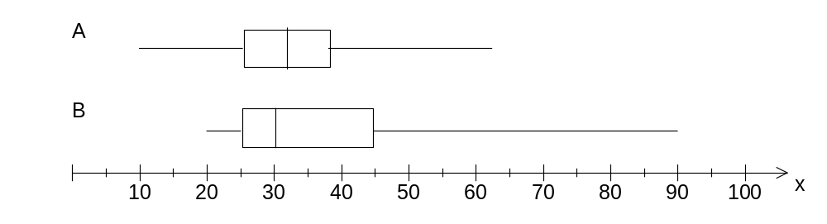
Write four statements comparing the distributions shown in the box plots above.

Question 14. (5 marks)

Tyson, a young man about town, is in the market for a new car and has narrowed his choice to four cars. The different aspects of the cars and the respective weightings placed by him are as follows.

 | Macho  rating | Acceleration | Price | All terrain  capability | Fuel economy
Weighting | 6 | 5 | 4 | 3 | 2
Car A | 7 | 6 | 6 | 4 | 7
Car B | 8 | 5 | 7 | 5 | 2
Car C | 8 | 7 | 6 | 5 | 5
Car D | 6 | 8 | 6 | 6 | 5

Calculate the weighted scores of the four cars.

Tyson will buy the car with the highest weighted score. Which one will he buy?

Question 15 (2 , 2 marks)

Skye has inherited $540 000 from her grandmother and will invest $500 000 in an account paying
3.5% per annum compounded half yearly. She plans to make only one withdrawal each year.

(a) For how many years will she be able to withdraw $40 000 a year from this account?

(b) If she would like the money to last for 20 years, how much will she be able to withdraw from the
account each year?

End of Part B
This page has been left blank intentionally.

This page has been left blank intentionally.

